Solutions To Hands-On Exercises

Java Fundamentals

**Setup Instructions:**

1. Create a new workspace - “Assignments” in Spring Tool Suite IDE.
2. Create a new Java Project called “FullStackDay1”.
3. Create your classes in the default package.
4. Define your classes as given below for each assignment.

Assignment 01

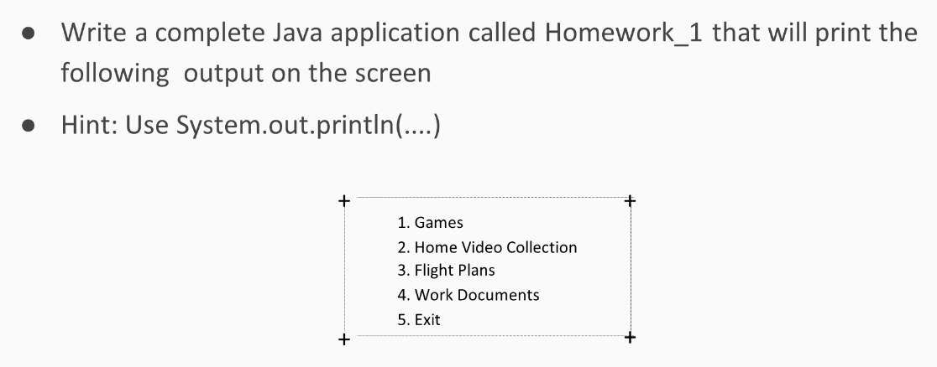

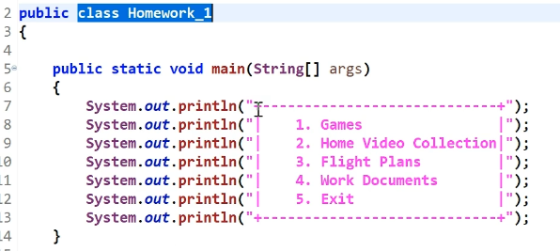

Output

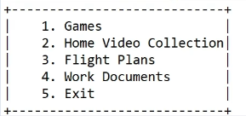

Assignment 02

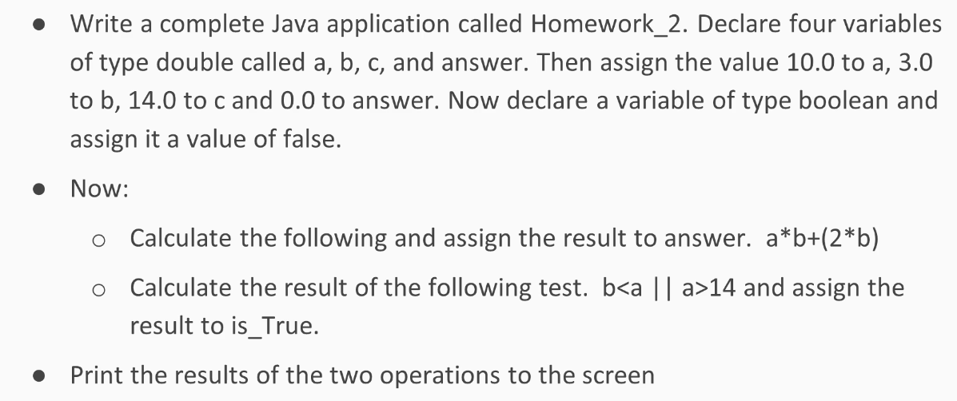

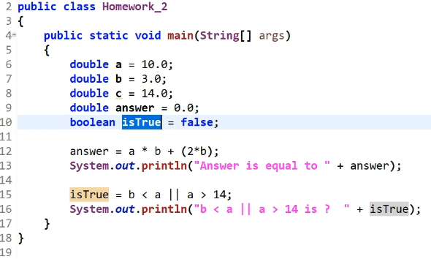

Output

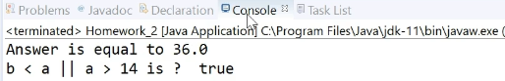

Assignment 03

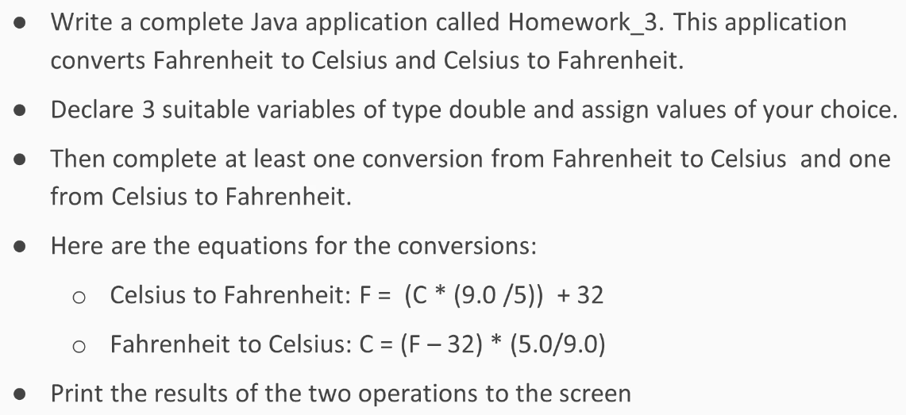

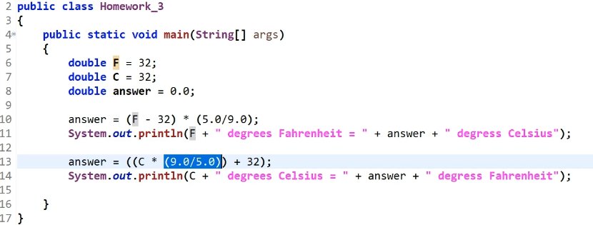

Output



